**Ogopogo Senior Slo-Pitch Tournament Registration Form**

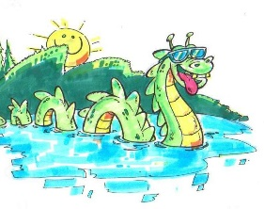

Please fill out the following information to register for the event.

All teams must be registered, and entry fee must be paid by 10 days prior to the start of the tournament so the tournament committee can finalize the tournament schedule.

Team Name ____________________ City ____________________ Date ____________________

Manager ______________________ Email ___________________ Cell _____________________

Mailing Address _____________________________________ Postal Code _____________________

Assistant Coach _________________ Email ___________________ Cell _____________________

Mailing Address _____________________________________ Postal Code _____________________

Teams must indicate with a check mark their desired division.

**Men’s 55’s ____ Men’s 60’s _____ Men’s 65’s _____ Men’s 70’s _____ Men’s 75+ _____**

**Women’s 55’s ____ Women’s 60’s _____ Women’s 65’s _____ Women’s 70’s _____ Women’s 75+ _____**

Note: Each age group may have up to three players, two years younger on their team.

Example: A 60’s team may have up to three 58-year-old players if they are 58 or turning 58 in that calendar year.

Every team wanting to register for this tournament should print out this registration form, fill it out, scan or download the filled-out document and send to Mike Sawka at [msawks@hotmail.com](mailto:msawks@hotmail.com)

Follow up sending in your registration by sending an e-transfer for $450 to Mike Sawka at msawks@hotmail.com

Registrations are confirmed by entry fee payment only.

Any questions feel free to contact Mike Sawka at [msawks@hotmail.com](mailto:msawks@hotmail.com) or call Mike at 250-307-3252

_____ I declare I as the team manager for ______________________________________ declare that my team meets the requirements for the Ogopogo tournament.

Team Mangers Signature ___________________________ Date __________________________

