Ogopogo Senior Slo-Pitch Tournament Registration Form
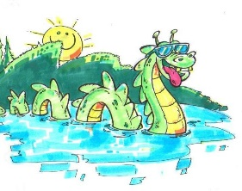
Teams need to fill out this form to register. Please fill out and follow the directions at the bottom of this page.
With this tournament now being a SSUSA qualifying tournament sanctioned by SPN, all Canadian teams must be registered with SPN and all individual players must sign the SPN waiver on the SPN site..
Any teams from USA need to be registered with their association.
Team Name ____________________ City ____________________ Date ____________________
Manager ______________________ Email ___________________ Cell _____________________
Mailing Address _____________________________________ Postal Code _____________________
Assistant Coach _________________ Email ___________________ Cell _____________________
Mailing Address _____________________________________ Postal Code _____________________

Indicate the teams desired division.
Men’s 55’s ____ Men’s 60’s _____ Men’s 65’s _____ Men’s 70’s _____ Men’s 75+ _____
Women’s 55’s ____ Women’s 60’s _____ Women’s 65’s _____ Women’s 70’s _____ Women’s 75+ _____

Note: Each age group can have up to 2 under age players within two years of entered age division.
Example: A 60’s team may have up to two 58-year-old players if they are 58 or turning 58 in that calendar year.
Every team wanting to register for this tournament should print out this registration form, fill it out and send to Mike Sawka at msawks@hotmail.com
Follow up sending in your registration by sending an e-transfer for $450 to Mike Sawka at msawks@hotmail.com
Registrations are only confirmed once entry fee payment has been made.
Any questions feel free to contact Mike Sawka at msawks@hotmail.com or call Mike at 250-307-3252

Team Mangers Signature ___________________________ Date __________________________

